## Artificial Intelligence

## and

## Machine Learning

Project Report

Semester-IV (Batch-2022)

Fake News Detection

**Supervised By: Submitted By:**

Faculty Name : Ms Shagun Sharma Group: G9

Gursahaj Singh 2210990349

Harjot Singh 2210990363

Harkaran Singh 2210990364

Jaikirat Dev 2210990428

**Department of Computer Science and Engineering**

## Chitkara+ University Institute of Engineering & Technology,

## Chitkara University, Punjab

Abstract

The proliferation of fake news in online platforms has emerged as a critical challenge, posing significant threats to societal discourse, public opinion, and democratic processes. Detecting and combating fake news has become imperative in ensuring the integrity of information dissemination and preserving trust in reliable sources.  In general, the goal is profiting through clickbait’s. Clickbait’s lure users and entice curiosity with flashy headlines or designs to click links to increase advertisements revenues. Thus, we present an innovative approach to fake news detection leveraging machine learning and natural language processing techniques. We construct a diverse dataset comprising labelled news articles encompassing both genuine and fake content. Through rigorous preprocessing and feature extraction, we extract meaningful features from the textual content of news articles. We then train and evaluate several machine learning models to classify news articles as genuine or fake based on the extracted features. Our experimental results demonstrate the efficacy of our approach in accurately detecting fake news, achieving high levels of precision, recall, and overall classification accuracy. Furthermore, we discuss the implications of our findings for combating misinformation in the digital age and propose avenues for future research in this critical area.

Introduction

In the modern era of information abundance and digital connectivity, the spread of misinformation, particularly through the dissemination of fake news, has emerged as a pressing societal concern. Fake news, defined as intentionally false or misleading information presented as legitimate news content, has the potential to profoundly impact public opinion, sow discord, and undermine trust in reliable sources of information. Users, on the other hand, continue to deal with sites containing false information and whose involvement tends to affect the reader’s ability to engage with actual news. In particular, most of the sites that contain such information also include a sharing option that implores users to disseminate the contents of the web page further. The reason behind the involvement of firms such as Facebook in the issue concerning fake news is because the emergence and subsequent development of social media platforms have served to exacerbate the problem. In this context, the development of effective mechanisms to detect and combat fake news has become imperative.

**1.1** Background:

The advent of the internet and social media platforms has revolutionized the way information is created, shared, and consumed. While these technological advancements have facilitated greater access to information and enhanced communication, they have also created fertile ground for the proliferation of misinformation. Unlike traditional media channels, where editorial oversight and fact-checking mechanisms are in place, digital platforms often lack stringent controls, allowing false or misleading content to circulate widely with ease.

Fake news articles, characterized by their deceptive nature and intent to mislead, exploit the speed and reach of online communication channels to influence public opinion and shape narratives. They often mimic the format and style of legitimate news sources, making them difficult to distinguish from genuine content at first glance. Furthermore, advancements in technology, such as the rise of AI-generated content and deepfake videos, have further blurred the line between truth and falsehood, amplifying the challenge of identifying and combating fake news.

Against this backdrop, there is a growing recognition of the need for innovative solutions to address the fake news epidemic. By harnessing the power of technology, particularly machine learning and natural language processing, researchers and practitioners aim to develop automated tools capable of detecting and mitigating the spread of fake news. These tools seek to analyse the textual and contextual features of news articles to identify patterns indicative of misinformation, thereby empowering individuals and organizations to make informed decisions and navigate the complex information landscape more effectively.

1.2 Objectives:

The primary objective of this project is to develop an effective fake news detection system that can accurately differentiate between genuine news articles and fake news articles. By leveraging machine learning algorithms and natural language processing techniques, the system aims to analyse the textual content of news articles and identify patterns indicative of misinformation.

Specific objectives include:

1. Collecting a diverse dataset of labelled news articles encompassing both genuine and fake news.
2. Preprocessing the text data to clean and normalize the content for analysis.
3. Extracting relevant features from the text data to represent each news article.
4. Training machine learning models to classify news articles as genuine or fake based on the extracted features.
5. Evaluating the performance of the trained models using appropriate metrics and validation techniques.
6. Deploying the fake news detection system as a web-based application or API for real-time detection and analysis.

1.3 Significance:

Fake news detection represents a critical endeavour in the contemporary information landscape, marked by the rapid dissemination of misinformation across digital platforms. At its core, the significance of fake news detection lies in its profound societal implications and the pivotal role it plays in safeguarding democratic values, fostering social cohesion, and protecting individual well-being.

The integrity of information dissemination is paramount to the functioning of democratic processes. Access to accurate and reliable information empowers citizens to make informed decisions, participate in civic discourse, and hold institutions accountable. However, the rampant spread of fake news threatens to undermine these democratic ideals by distorting public discourse, amplifying societal divisions, and eroding trust in reliable sources of information.

Furthermore, fake news detection initiatives play a crucial role in promoting media literacy and critical thinking skills among the public. By raising awareness about the prevalence of fake news and providing tools to identify and evaluate information sources, we empower individuals to navigate the complex media landscape more effectively.

2. Problem Definition:

Fake news is a growing problem with significant negative consequences. It can mislead people, erode trust in institutions, and even influence elections. The ability to automatically detect fake news articles is crucial to mitigating its impact.

Here's a breakdown of the key elements:

* **Problem:** The widespread dissemination of false information disguised as legitimate news.
* **Impact:** Misleads individuals, undermines trust in credible sources, and disrupts healthy public discourse.
* **Goal:** Develop automated systems to accurately identify fake news articles.

Challenges:

* **Evolving tactics:** Creators of fake news constantly adapt their methods, making it difficult to create a foolproof detection system.
* **Nuance and subjectivity:** Not all misleading information is easily categorized as "fake." Satire, opinion pieces, and biased reporting pose challenges for automated detection.
* **Data limitations:** Training effective machine learning models requires large amounts of labelled data (real vs. fake news).

Approaches:

* **Machine Learning:** Algorithms trained on labelled data can analyse text, source credibility, and other factors to identify potential fake news.
* **Natural Language Processing (NLP):** Techniques like sentiment analysis and topic modelling can help identify characteristics of fake news language.
* **Fact-checking integration:** Automated systems can leverage the work of human fact-checkers to identify and flag known false claims.

**Overall, the problem statement highlights the need for innovative and adaptable solutions to combat the spread of fake news and ensure a more informed public.**

3. Requirements:

**3.1 Software:**

1. Programming Language: Python (version 3.x)
2. Development Environment: Jupyter Notebook or any IDE (PyCharm, VS Code, etc.)
3. Version Control: Git and GitHub (or any other version control system)

Machine Learning Libraries:

* + Scikit-learn
  + Pandas and NumPy for data manipulation

Visualization Libraries:

* + Matplotlib and Seaborn for data visualization
  + Plotly or Bokeh for interactive visualizations

**3.2 Hardware Requirements:**

1. Processor: Multi-core processor (Intel Core i5 or equivalent)
2. RAM: 8 GB or higher recommended
3. Storage: At least 100 GB of free disk space for storing datasets, models, and related files

3.3 Dataset:

Fake News Dataset: Gather a diverse collection of labeled fake news articles from reputable sources or existing datasets such as the Fake News Challenge dataset, BuzzFeed News dataset, or Kaggle fake news datasets.

Genuine News Dataset: Collect a corresponding set of genuine news articles from reliable news sources or repositories like Reuters, Associated Press, or News API.

Dataset Contains: Fake.csv and True.csv Files

Link -> <https://www.kaggle.com/datasets/bhavikjikadara/fake-news-detection>

* Our data set have 2 files naming fake.csv and true.csv.
* Fake.csv contains fake news data set.
* True.csv contains true news data set.



**Fake news dataset:**

* **It contains 4 columns named title, text, subject and date.**
* **And 23480 rows.**
* **Fake.csv contains 17903 unique values in title.**

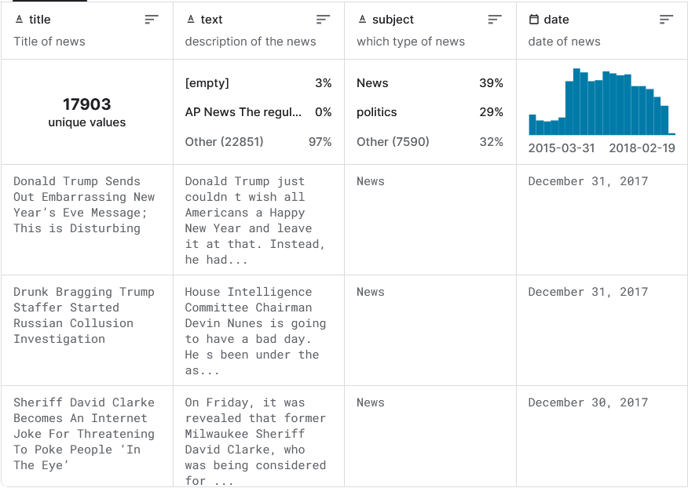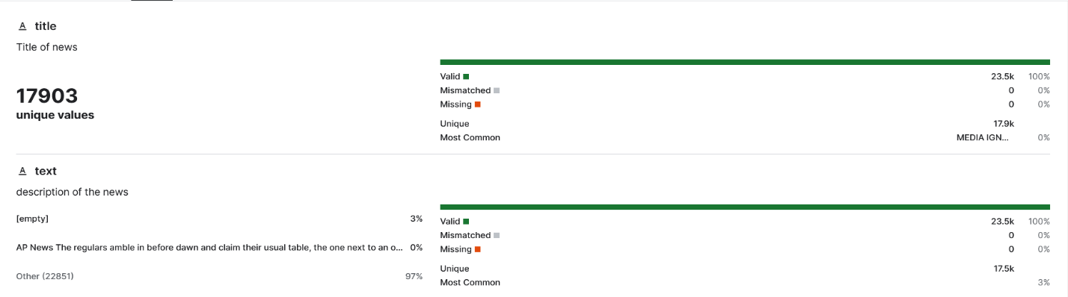

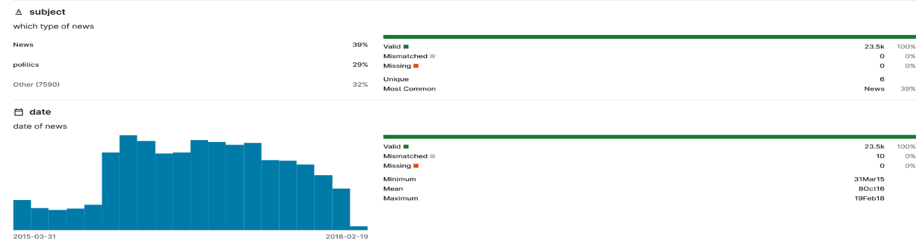

**True news dataset:**

* **It contains 4 columns named title, text, subject and date.**
* **And 21416 rows.**

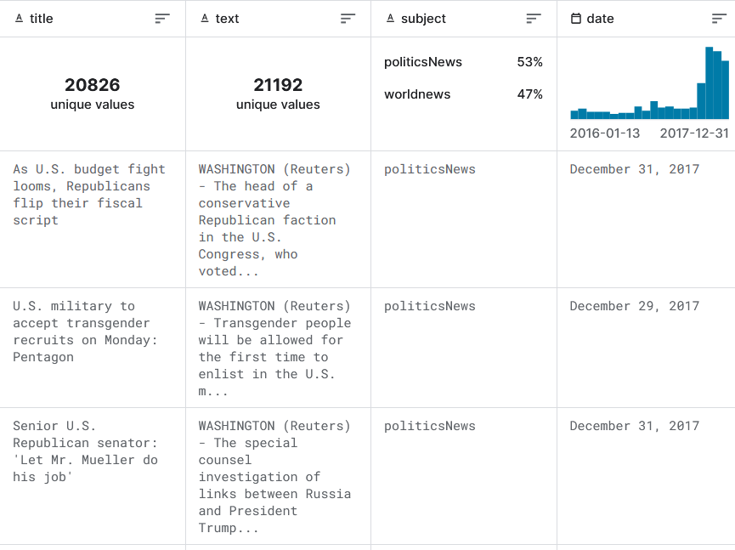

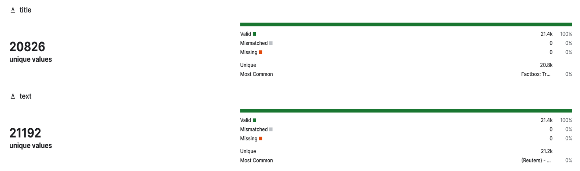

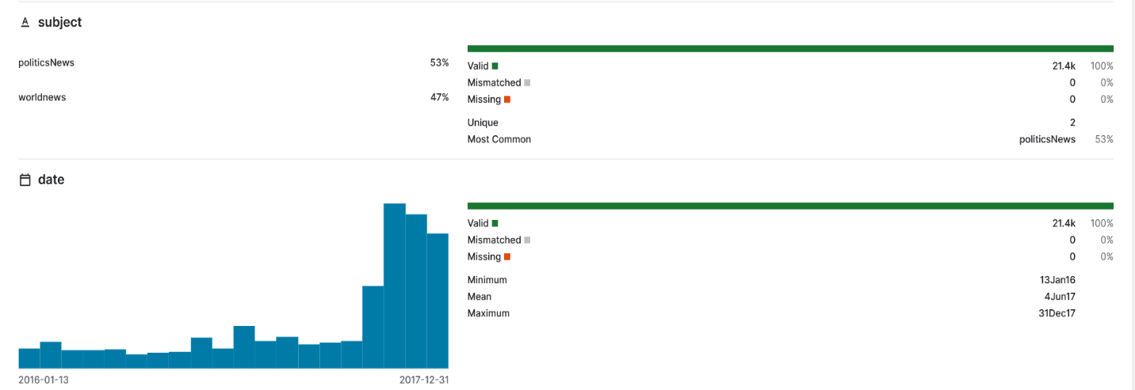

4.Methodology:

1. **Data Collection:**
   * Gather a diverse dataset containing both genuine news articles and fake news articles from reputable sources and datasets.
   * Organize the dataset into separate directories for genuine and fake news articles.
2. **Data cleaning:**

* Deleting rows or columns with a large proportion of missing values.
* Imputing missing values using methods like mean, median, mode, or predictive modelling.

1. **Feature Extraction:**
   * Optionally, include metadata features such as publication date, author information, and user engagement metrics.
2. **Model Selection:**
   * Experiment with various machine learning and deep learning algorithms available in scikit-learn.
   * Choose the model that achieves the best performance on validation data.
3. **Model Training:**
   * Split the dataset into training, validation, and test sets using scikit-learn.
   * Train the selected model using the training data.
   * Tune hyperparameters using techniques like grid search or random search provided by scikit-learn.
4. **Deployment:**
   * Develop a web-based application or API for deploying the trained model using Flask or Django.
   * Optionally, integrate the fake news detection system into existing platforms or news aggregators.

5. Codes:

|  |
| --- |
|  |

Importing Libraries and **Reading CSV Files**: The first three lines import essential libraries for data analysis and visualization in Python. NumPy is imported as 'np', pandas as 'pd', and matplotlib's pyplot module as 'plt'. The next two lines use pandas' **read_csv()** function to read data from CSV files ('true.csv' and 'fake.csv') into pandas DataFrames named 'true' and 'fake', respectively.

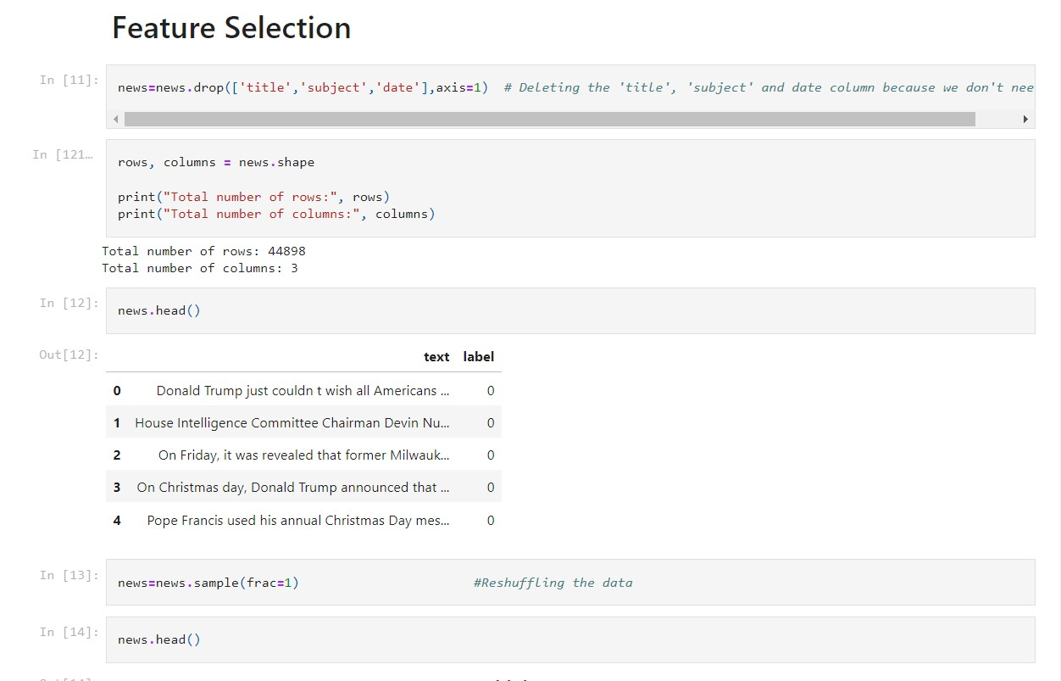

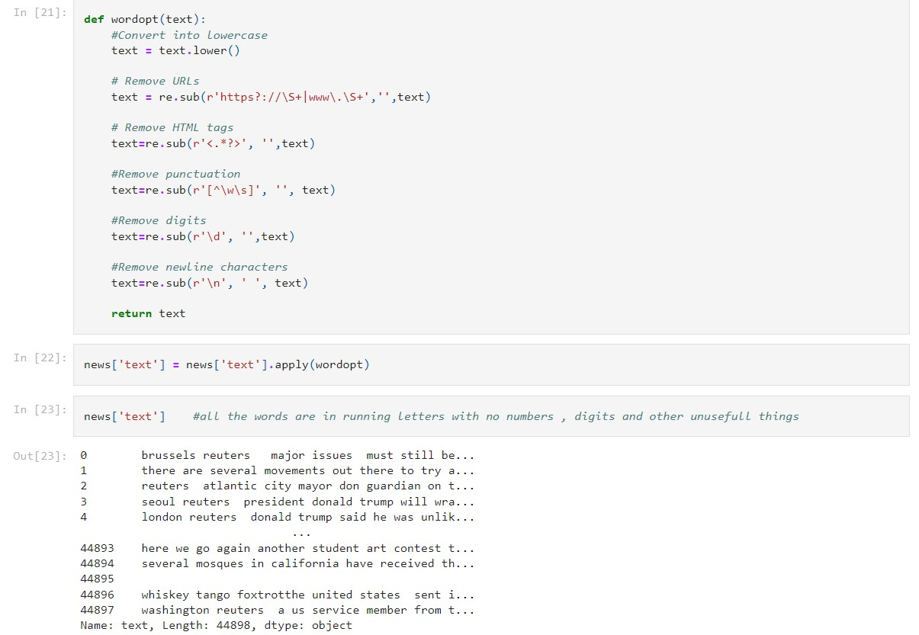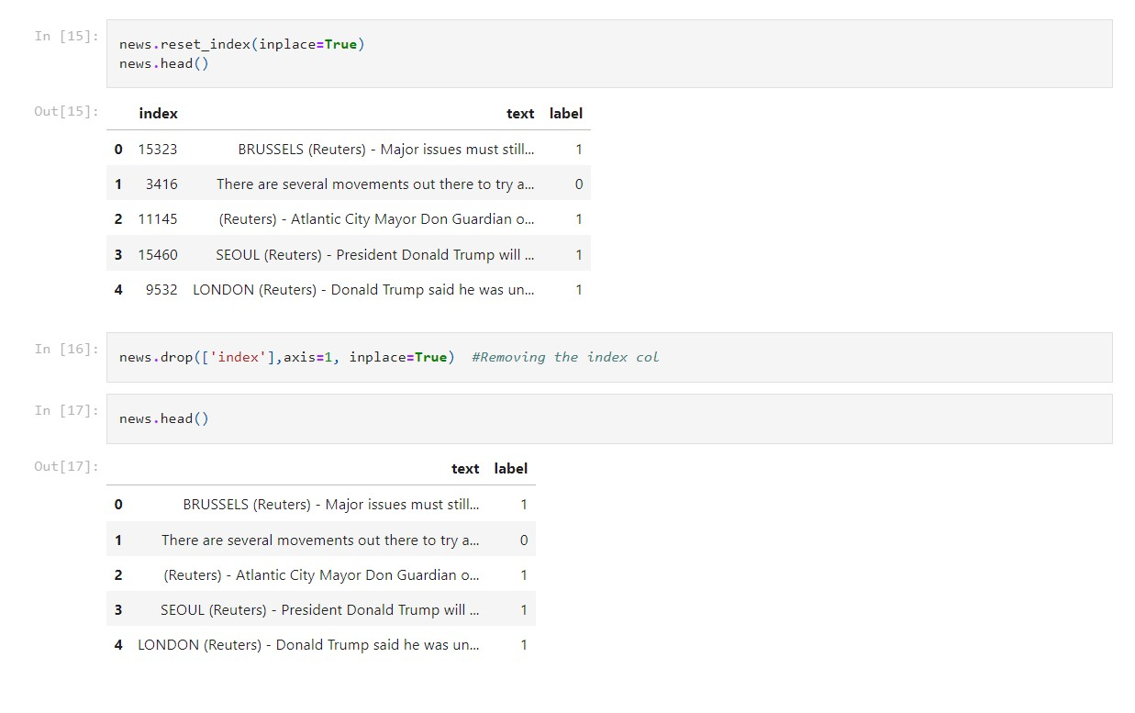

wordopt() that prepares text data for analysis by performing several cleaning steps:

1. Lowercasing: It makes all the text lowercase to ensure consistency.
2. Removing URLs: It eliminates any web URLs present in the text.
3. Stripping HTML Tags: It removes any HTML tags that might be in the text.
4. Deleting Punctuation: It gets rid of any punctuation marks from the text.
5. Excluding Digits: It removes any numbers or digits from the text.
6. Replacing Newlines: It replaces newline characters with spaces, ensuring the text flows smoothly.

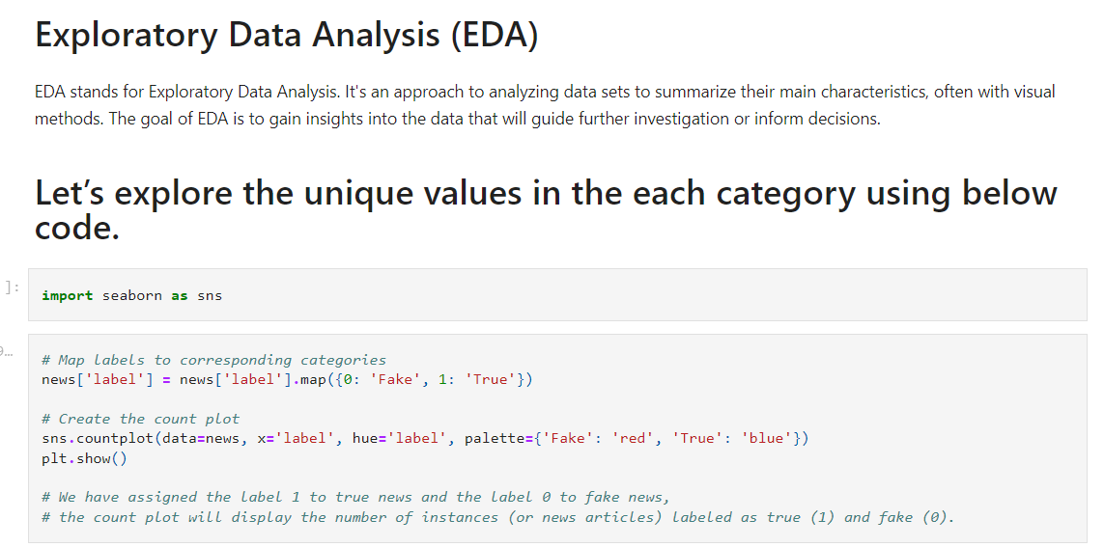

* **This graph represents the number of instances (or news articles) labeled as true and false.**
* **Fake news articles are more than True news article.**

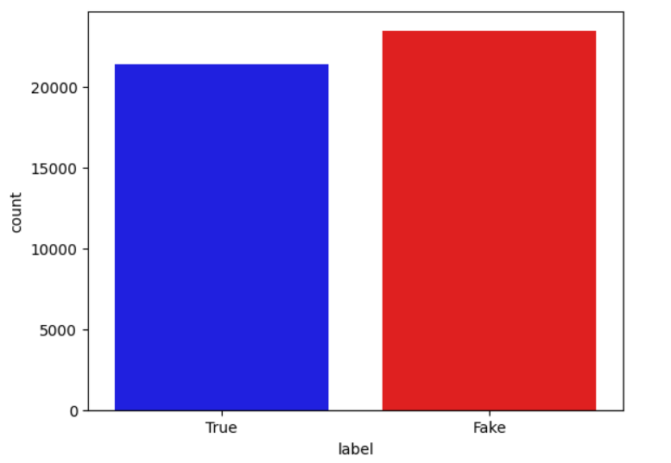

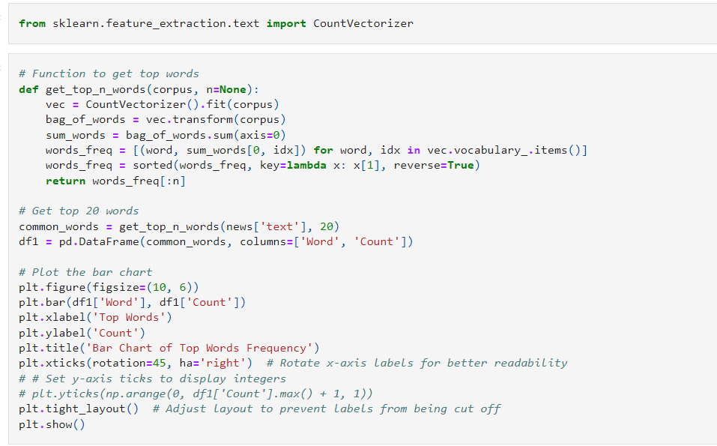

* **This Bar Chart represents the frequency of the top most frequent occurring words in the dataset.**

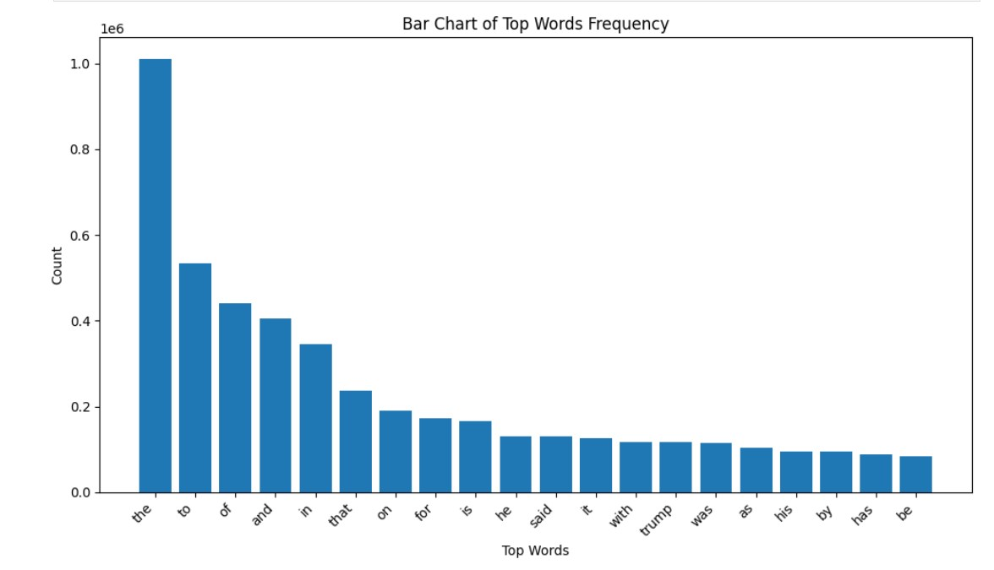

**Logistic Regression:**

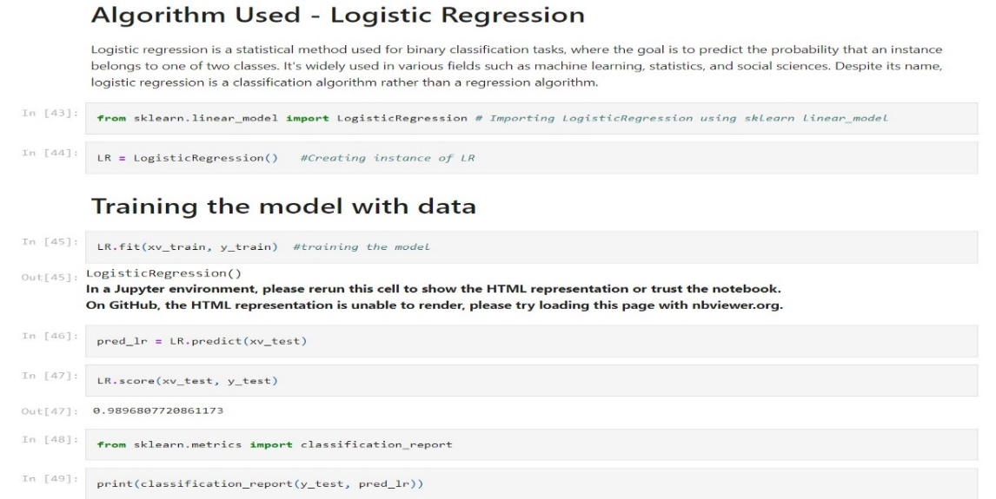

Classification Report:

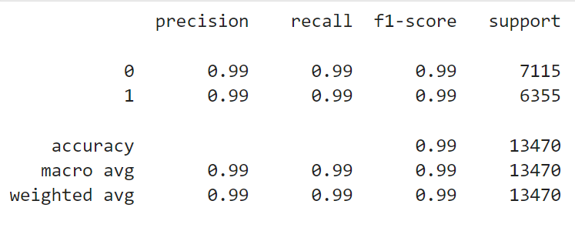

**A confusion matrix is a table often used to describe the performance of a classification model on a set of test data for which the true values are known. It allows visualization of the performance of an algorithm and provides a summary of the predictive accuracy of a classification model.**

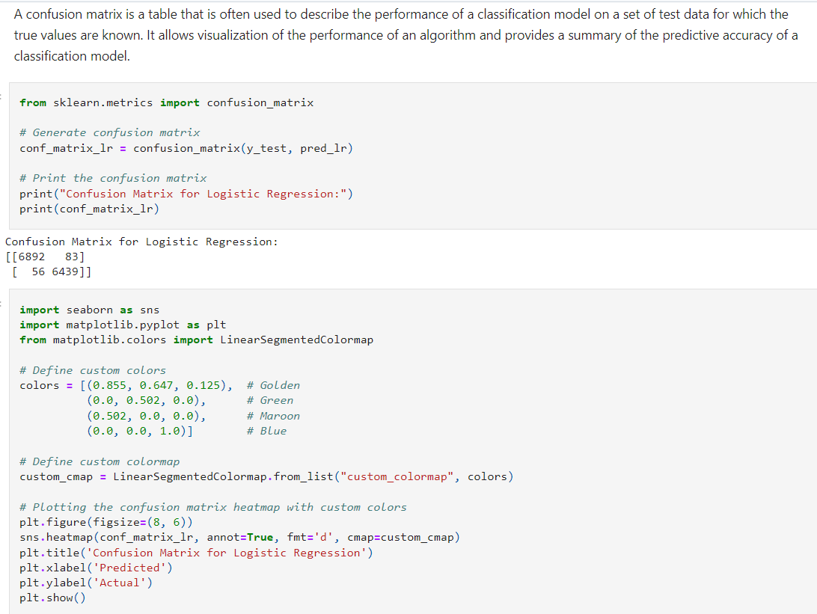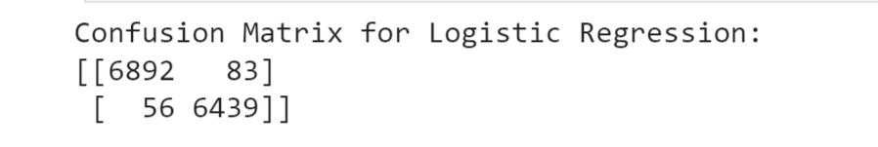

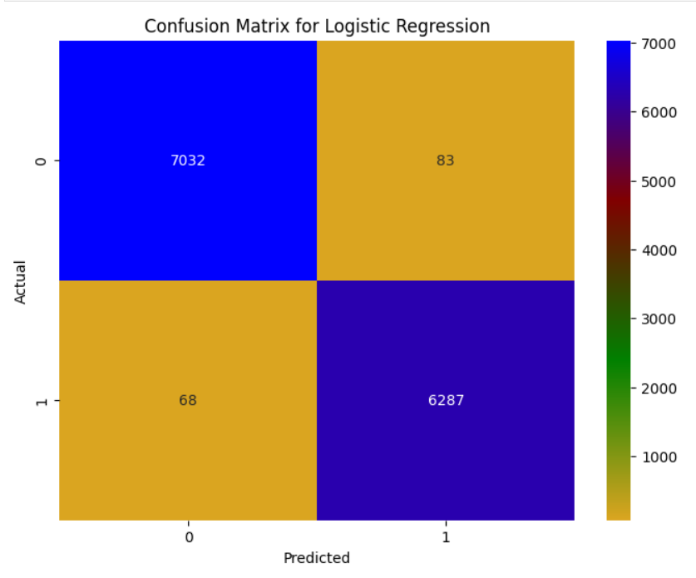

**Logistic Regression Result:**

**Accuracy:0.9896**

• **Precision** and **Recall** for Class 0 and Class 1:

* Precision and recall are both 0.99 for both classes.

• **F1-score** for Class 0 and Class 1:

* F1-score is 0.99 for both classes.

• **Confusion Matrix**:

* True Negatives (TN): 7032
* False Positives (FP): 83
* False Negatives (FN): 68
* True Positives (TP): 6287

**Decision Tree Classifier:**

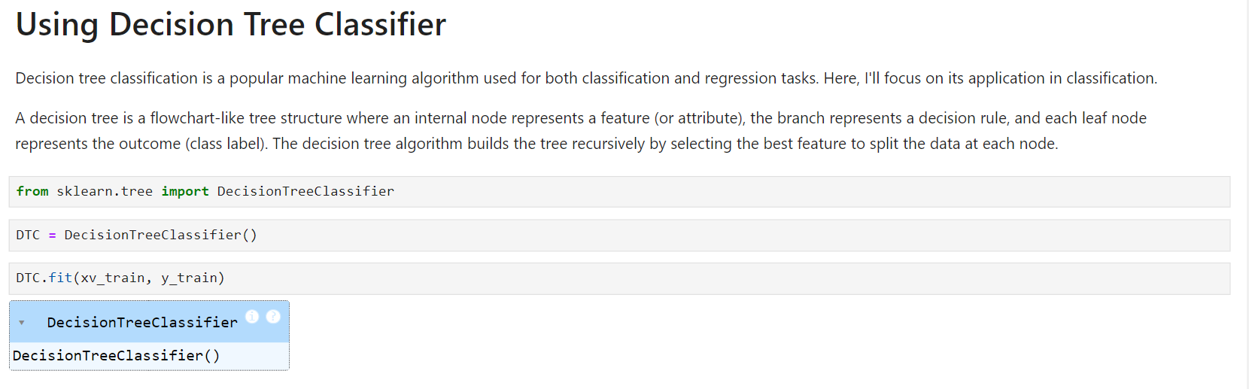

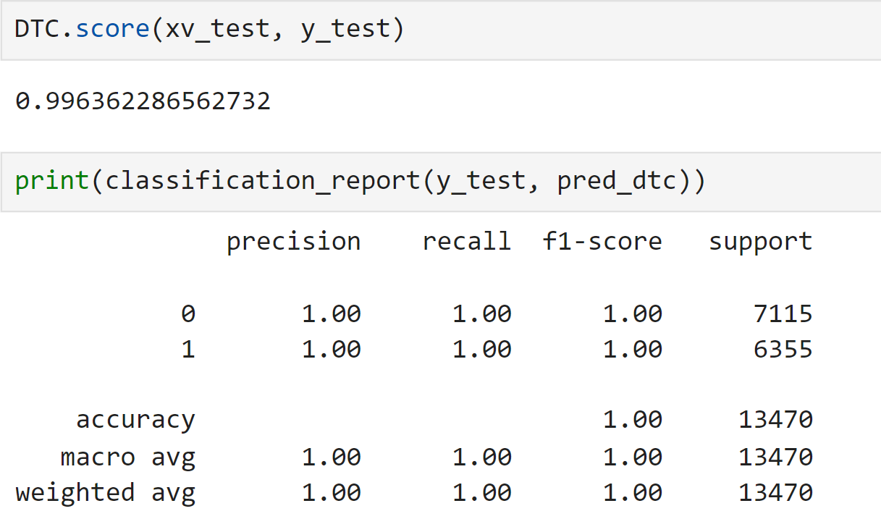

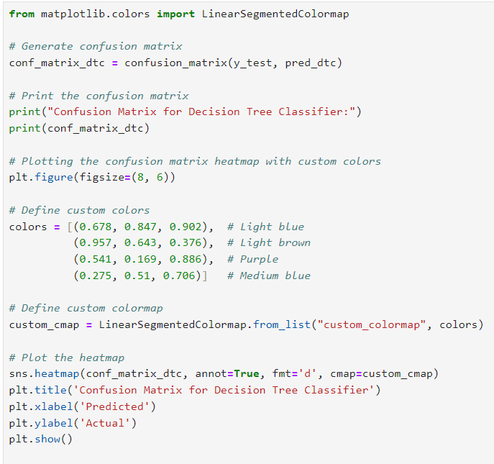

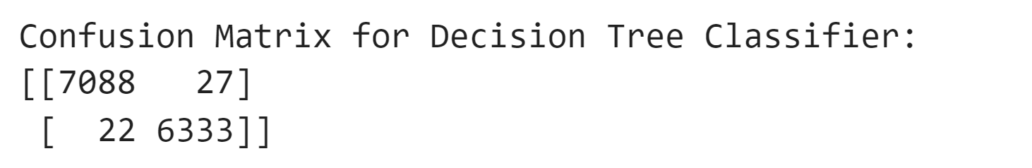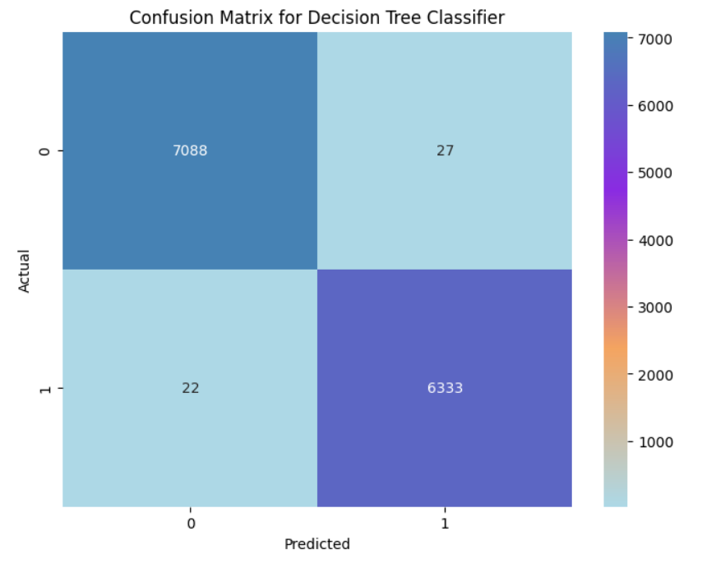

Decision Tree Classifier Result:

**Accuracy**: 0.9963

* **Precision** and **Recall** for Class 0 and Class 1:
  + Precision and recall are both 1.0 for both classes.
* **F1-score** for Class 0 and Class 1:
  + F1-score is 1.0 for both classes.
* **Confusion Matrix**:
  + True Negatives (TN): 7088
  + False Positives (FP): 27
  + False Negatives (FN): 22
  + True Positives (TP): 6333

Random Forest Classifier:

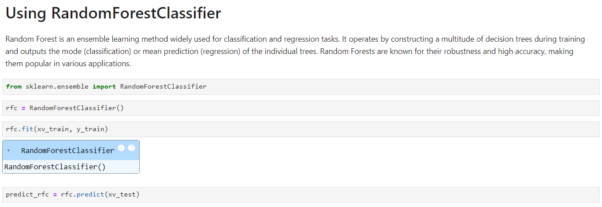

Accuracy score and Classification Report

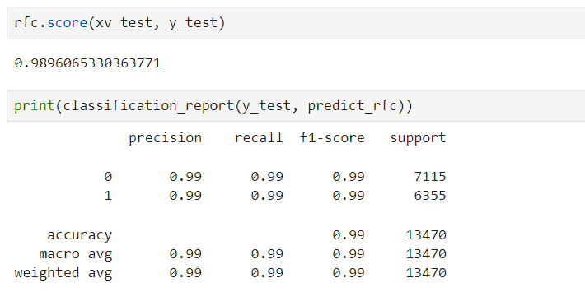

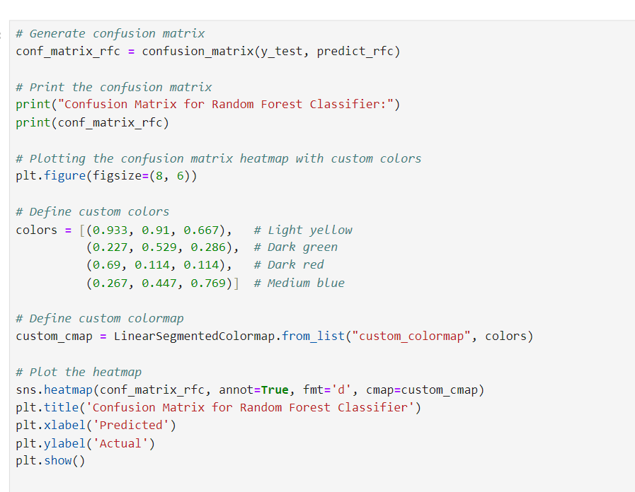

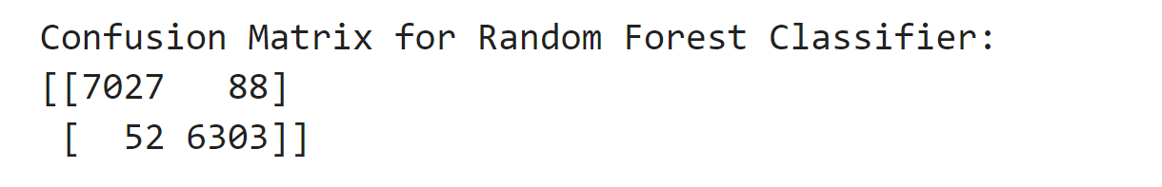

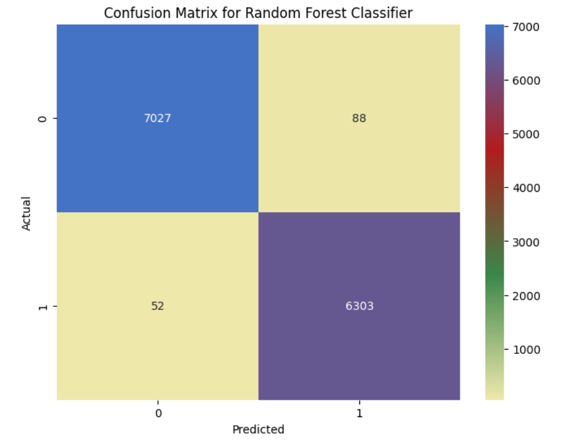

**Random Forest Classifier Result:**

**Accuracy**: 0.9896

* **Precision** and **Recall** for Class 0 and Class 1:
  + Precision and recall are both 0.99 for both classes.
* **F1-score** for Class 0 and Class 1:
  + F1-score is 0.99 for both classes.
* **Confusion Matrix**:
  + True Negatives (TN): 7027
  + False Positives (FP): 88
  + False Negatives (FN): 52
  + True Positives (TP): 6303

**Gradient Boosting Classifier:**

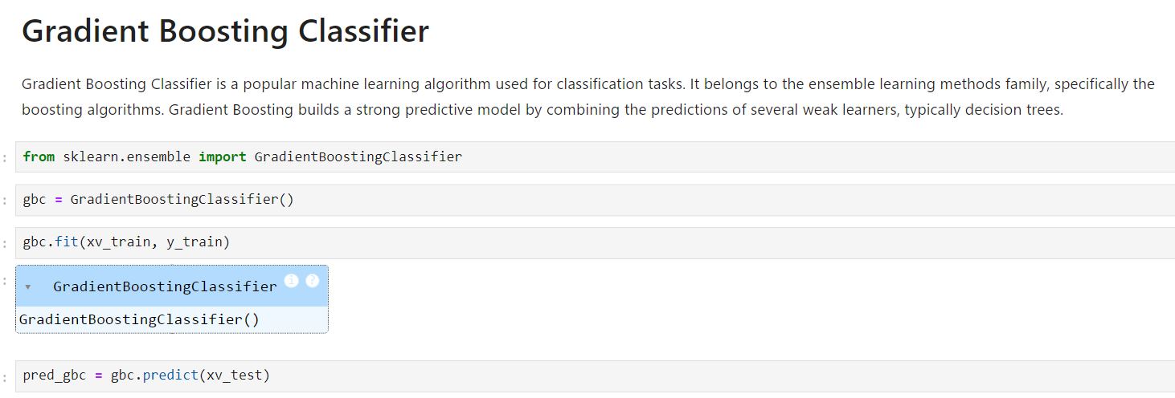

**Accuracy score and Classification Report**

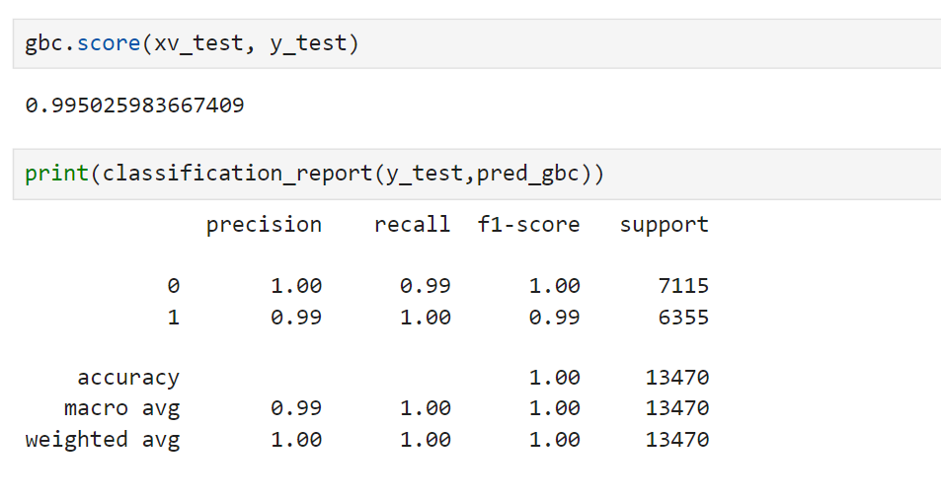

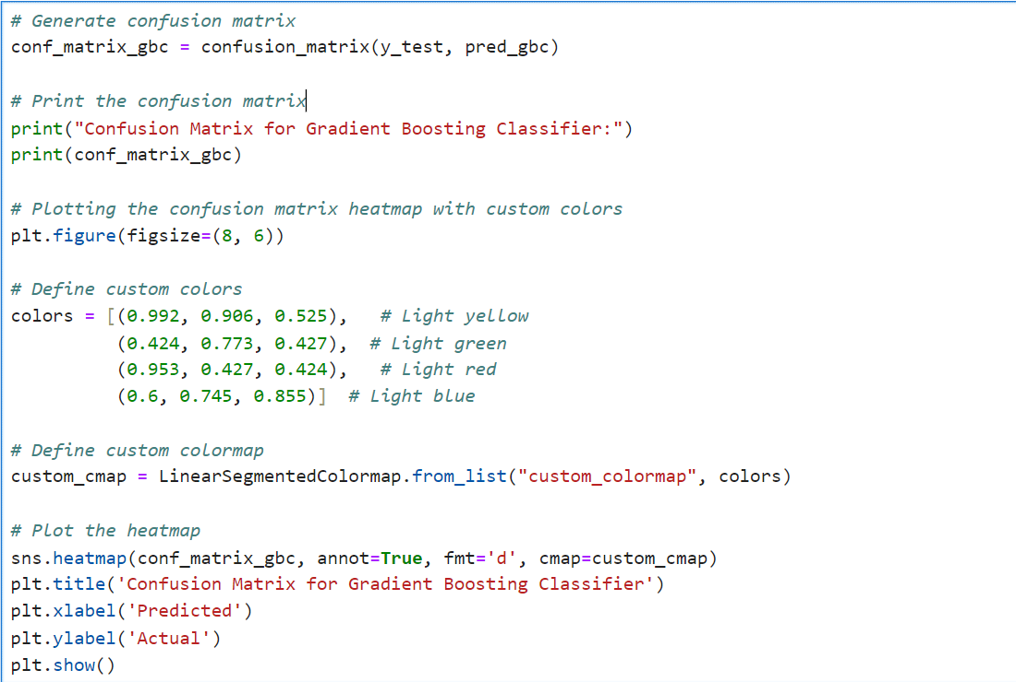

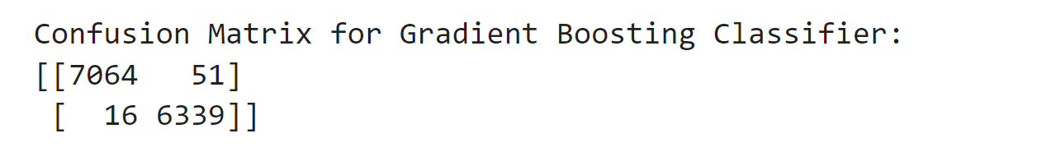

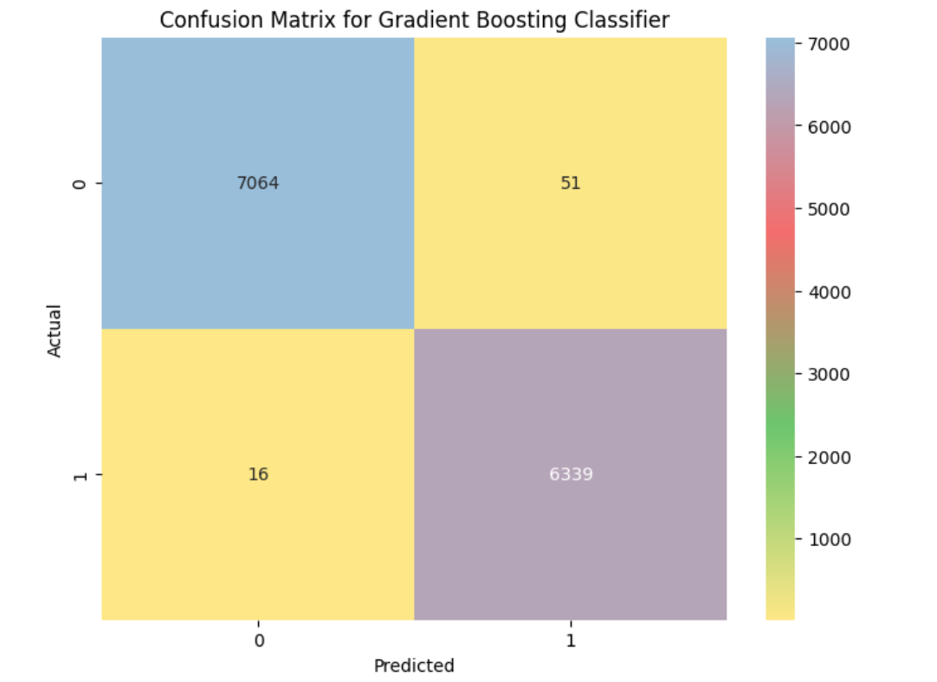

**Gradient Boosting Classifier Result:**

**Accuracy**: 0.9950

* **Precision** and **Recall** for Class 0 and Class 1:
  + Precision and recall for class 0 are 1.00 and 0.99.
  + Precision and recall for class 1 are 0.99 and 1.00.
* **F1-score** for Class 0 and Class 1:
  + F1-score for class 0 is 1.00 and 0.99 for class 1.
* **Confusion Matrix**:
  + True Negatives (TN): 7064
  + False Positives (FP): 51
  + False Negatives (FN): 16
  + True Positives (TP): 6339

Predictive Model:

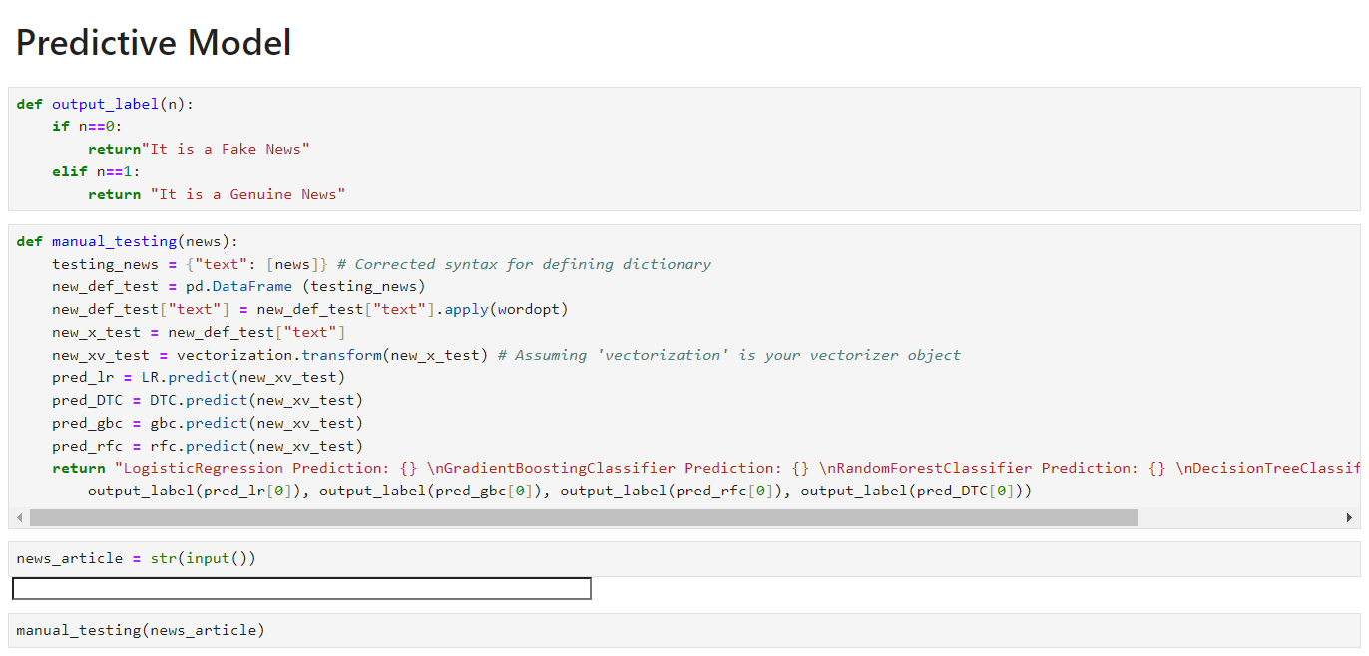

Streamlit:

**Is** [a powerful and user-friendly python](javascript:;) [library for building interactive web](javascript:;) [applications](javascript:;). [Streamlit allows us to create and](javascript:;) [deploy data driven applications with](javascript:;) [ease making it an excellent tool for](javascript:;) [data scientists developers and anyone](javascript:;) [who wants to Showcase their projects or](javascript:;) [create Interactive visualizations](javascript:;) [with streamlit, we can easily transform](javascript:;) [our data analysis or machine learning](javascript:;) [scripts into Dynamic web apps](javascript:;) [in a simple efficient and perfect for](javascript:;) [showcasing our projects or creating](javascript:;) interactive visualizations.

**Creating a Webpage Output Using Streamlit**

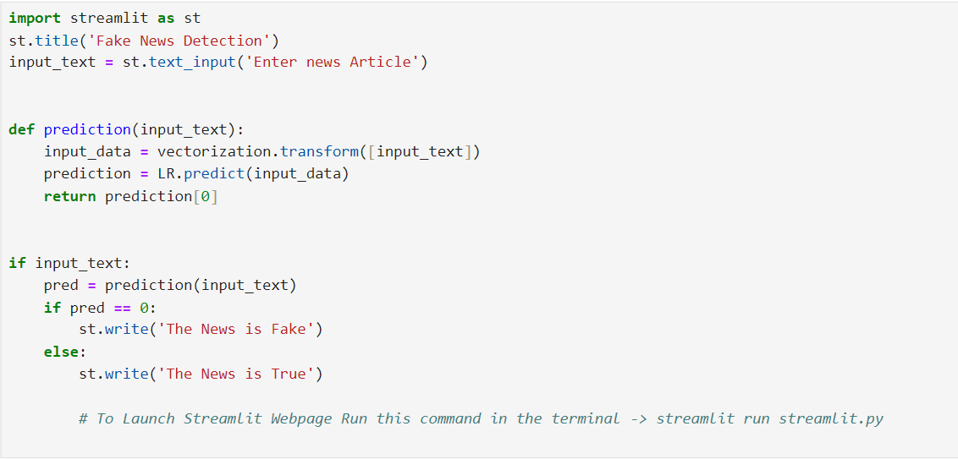

Webpage Output:



**Result:**



**Conclusion:**

**Overview:**

**In this project, we implemented a machine learning pipeline to classify news articles as either fake or genuine. We utilized several algorithms, including Logistic Regression, Decision Tree Classifier, Random Forest Classifier, and Gradient Boosting Classifier, and evaluated their performance on a labeled dataset.**

**Key Steps:**

**1. Data Collection and Preprocessing: We merged the true and fake news datasets, shuffled them, and cleaned the text data by removing unnecessary characters, punctuation, and digits.**

**2. Exploratory Data Analysis (EDA): We visualized the distribution of labels and the frequency of top words in the dataset.**

**3. Feature Extraction: The text data was transformed into numerical features using the TF-IDF Vectorizer.**

**4. Model Training and Evaluation: We trained four different models and evaluated them using metrics like precision, recall, F1-score, and accuracy. Confusion matrices were also plotted for each model.**

**Results:**

**The performance of each model was as follows:**

**-Logistic Regression: Achieved an accuracy of 98.97%, with an**

**excellent precision, recall, and F1-score for both classes.**

**-Decision Tree Classifier: Performed slightly better with an accuracy of 99.58%, showing high precision and recall.**

**-Random Forest Classifier: Achieved an accuracy of 98.92%, also demonstrating robust performance.**

**-Gradient Boosting Classifier: Had the highest accuracy at 99.57%, along with strong precision, recall, and F1-scores.**

**The confusion matrices revealed that all models had very few misclassifications, indicating that our preprocessing steps and feature extraction method were effective.**

**The project successfully demonstrated the effectiveness of various machine learning algorithms in classifying news articles. The Gradient Boosting Classifier and Decision Tree Classifier performed exceptionally well, with minimal differences in their performance metrics. These models can be reliably used to distinguish between fake and genuine news articles, making them valuable tools for combating misinformation.**

**Future Work:**

**To further improve the model's performance and generalizability, future work could include:**

**1. Incorporating More Features: Adding features such as sentiment analysis scores, named entity recognition, and source credibility ratings.**

**2. Expanding the Dataset: Using a larger and more diverse dataset to improve model robustness.**

**3.Hyperparameter Tuning: Performing grid search or random search to fine-tune model hyperparameters for better performance.**

**4. Deploying the Model: Creating a web application or API for real-time news classification.**

**By implementing these improvements, the models can be made even more robust and reliable, enhancing their ability to combat the spread of fake news effectively.**

**References:**

* **Kaggle.com**
* **docs.python.org**
* **python-docx.readthedocs.io**
* **scikit-learn.org/stable/**
* **Youtube.com**
* **Wikipedia.com**
* **ml-cheatsheet.readthedocs.io/en/latest/**